Quick Reference

Here is a quick reference for using the Ankota Family member application For help: call your home care agency or support@ankota.com or 844-4-ANKOTA (844-426-5682 ext.1).

Admin Functions | How to Do it
Access the system | https://ankota.net (works on phone, tablet, or computer)  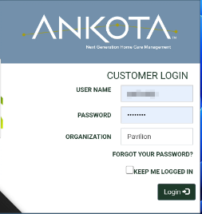  Please enter the username and password provided by your home care agency. It will mostly likely be your email as the username, and password as the default password. Lastly you will need to enter your “organization” which is the name or abbreviation of your home care company (like Pavilion)
Change your password | 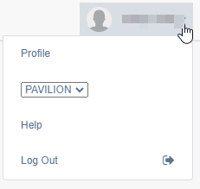  On the upper right of the screen you’ll see your name with a drop down arrow. Click on the drop own arrow and then choose profile to change your password.
Main View – Current Visit  - You will see the visit in progress or most recently completed visit  - To see the previous visit click “View Previous Visit” on the bottom  - To see the next visit, click on “View Next Visit” on top | 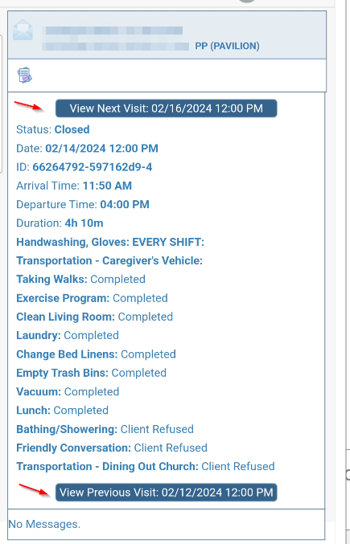

Schedule View  - Click the icon above the visit view to access the schedule | 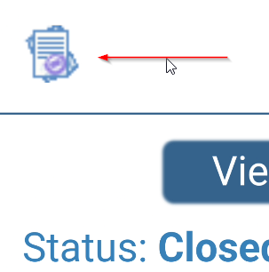
- On a phone the schedule will be in “rows” of data | 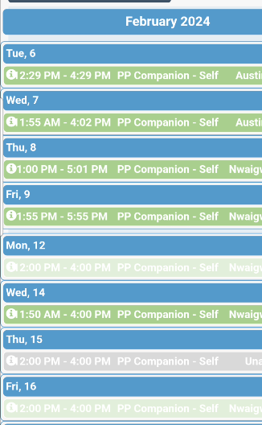
- On a laptop or tablet it will be a calendar view | 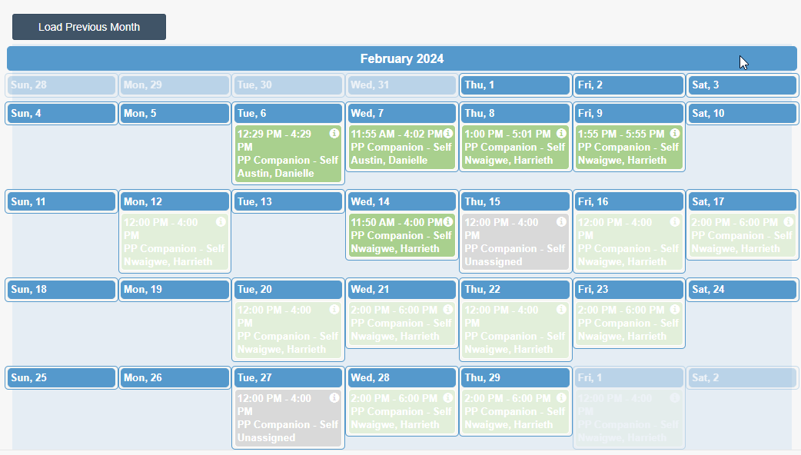
Message the Office  - Click on the envelope icon to the left of your client’s name | 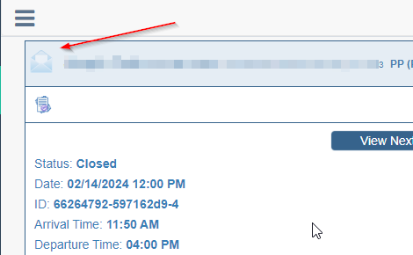
- Check the checkbox next to your home care agency name,  - Type your message and  - press send | 